Hi, it has been a while since my last newsletter, so here is the bumper Christmas edition, with lots of pictures and hopefully not too much text.
Paul and I have stopped cruising around all year and are now moored up in Banbury on the old arm of the South Oxford Canal. Low interest rates resulting from the Credit-Crunch meant our savings were idling so we decided to take the plunge into the historic narrow boat world.
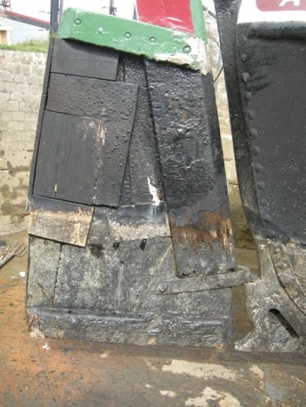
Welcome Atalanta – a 72ft “Butty” which means unpowered craft in boat-speak; built in 1935 by Harland and Wolfe, who also built the Titanic (we reckon we should be safe as no icebergs on the canals). It finished its working life in the 1970s and was converted as a live-aboard in the 80s. The hull of the boat is riveted iron, but the cabin and top is made of wood. It is a bit tatty, well quite tatty actually and needs a lot of TLC (and cash).
The first thing we had to replace was the rudder, a condition of getting the boat insured! The old one was a patchwork of wood ,and rather soft in places. We went to Rex Wain for our new rudder. He is at Brinklow Boats who specialise in the restoration of historic narrow boats. You can see from the photo the rudder is fairly substantial, made of wood with a solid oak stem post.
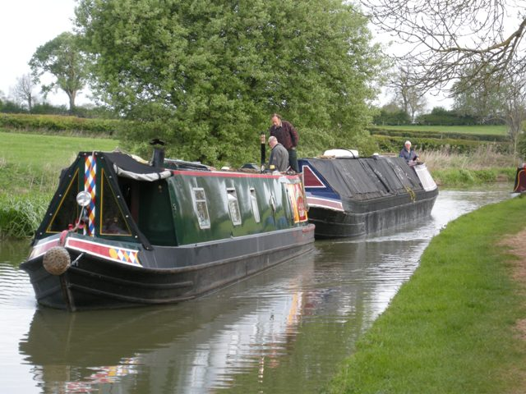
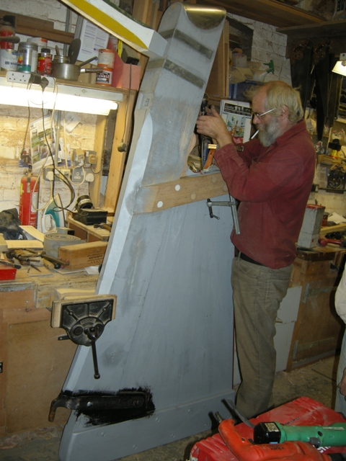And yes, a new dog, well we had to didn’t we? Meet Charlie our 17 month rescue scruffy “Oxfordshire Terrier” and isn’t he is gorgeous?
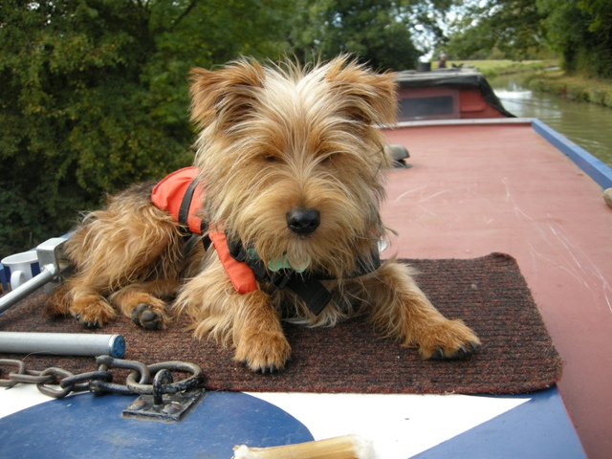
Here he is wearing his life-jacket, lying on top of the butty roof. He is just the right size for a boat.
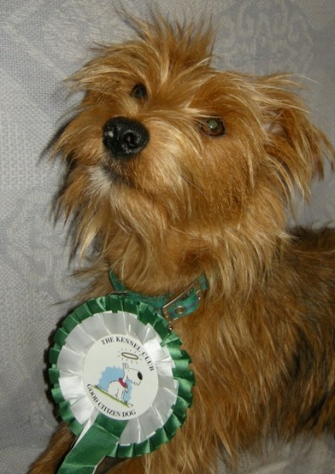
He is a clever dog though, and has just passed his Kennel Club Bronze and Silver Awards. Here is a photo of Charlie with his rosette.
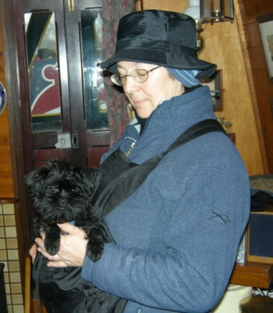
Talking of dogs, I have started a new venture caring for people’s pets. It goes under the name of RBC Pet care Services, RBC - stands for The Roaming Boat Co. Ltd: our new company which we set up earlier this year mainly for our consultancy. We have bought a smart grey van, the "dogmobile”, so that I can get about.
Oh and do you remember little “Eddie” the Affenpinscher puppy, who I helped to train as a diabetic alert and response dog?
Well, he has completed his training and is now living and working in Tring.
I am also doing some dog training at a local club, which keeps Charlie and I busy on a Sunday - while Paul works on restoring the butty.
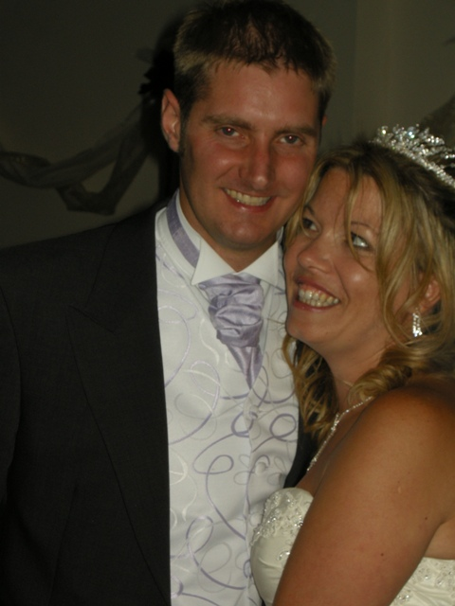
We saw a lot of Paul’s family this year, especially his brother Chris who celebrated his 30th birthday, with (dad) Ray on a hovercraftng activity afternoon. This was followed by hen and stag parties for Chris and his fiancé Kerry, leading up to the big day in August.
It was a fabulous wedding in a great venue and everything went like clockwork. The weather was sunny and breezy, and we were able to sit out on the patio in the evening. We stayed over, so were able to relax and enjoy a few drinks. Paul enjoyed himself so much he danced with me and even sang along to the records! Here is Paul with his brothers and dad, Ray – who scrubbed up quite well.
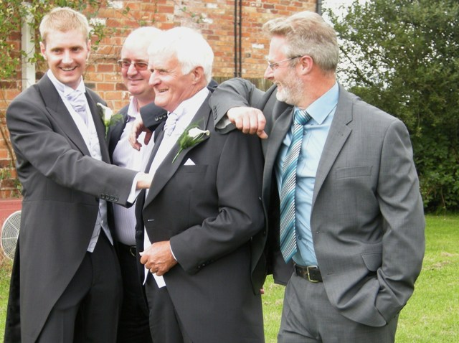
My brother Simon and I managed a trip up to Yorkshire in early May, where we met up with the Wooler family. Some distant relations had got in touch via the blog and we all met up in Settle to look at the family history on my birthday. Uncle John kindly organised the venue and cousin Sue put us up. Here we all are and thanks to George and Nikki for making the trip down from Cumbria.
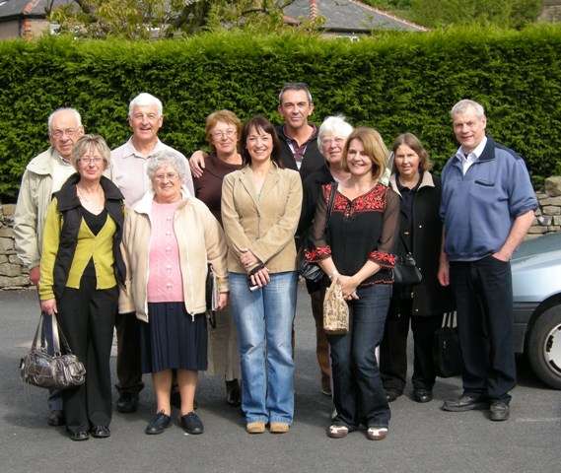
Hope to be able to catch up with you sometime next year. Wishing you a Merry Christmas and a Happy New Year. (Must go I have couscous to make). Love from Karen and Paul.

