July has been a quiet month as far as boating is concerned. It’s been great for seeing family though, and the main event was the Wooler family reunion on Sunday 8 July.
My dad, Brian Wooler, was one of nine - 6 boys and 3 girls. He and my mother had 4 children (3 girls and 1 boy), of whom I’m the eldest. I have 3 sons (Dan, Dave and Nic); my sister Julie and her husband Kaz have a boy and a girl (Katy and Tom); my sister Lucy and husband Mike have 2 boys (Matt and Andy); and our brother Simon is still unattached, eligible and available!
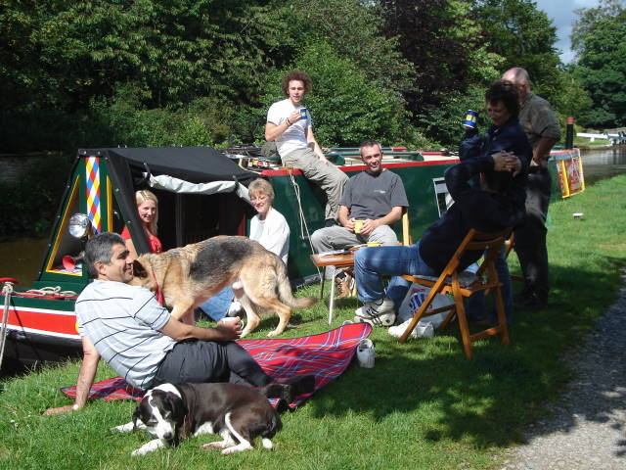Dad and Mum are no longer with us, but all of us managed to travel by boat, car and plane up to Yorkshire for the large family reunion. We had a mini reunion on the towpath at Gargrave on Saturday afternoon. A delicious lunch for 14 was ably prepared by Paul and thank goodness for fine weather as it would have been impossible to squeeze everyone onto the boat.
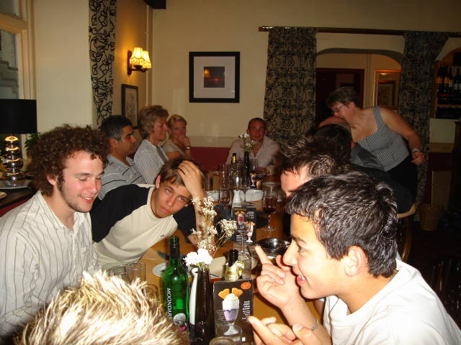We met up again at the pub in Kirkby Malham (a tiny hamlet where dad was born) for supper. My son Nic has been so lucky to inherit his mother’s hair; he may regret the photos in later years!
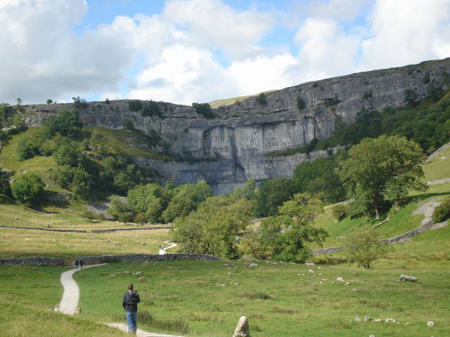Sunday dawned, dry and sunny so we made a pilgrimage to Malham Cove and walked the places that Dad would have known when a boy. The 300+ steps to the top proved a challenge after the previous day’s indulgences.
We then drove over the top of the moor on the single track road to Kettlewell (film location for Calendar Girls). We joined over 100 Woolers and friends in the village hall for drinks and a sumptuous lunch organized by Uncle Peter, Aunt Louise and their 4 sons and families. They had flown over from the Sates for a holiday and it was very kind of them to spend so much of their precious holiday time preparing food - and taking a turn behind the bar!
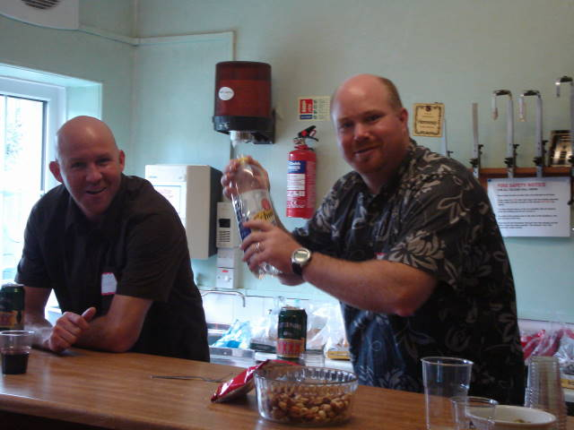Monday - and a roast lunch with Aunt Marge, Uncle Pat at their farm at Brimham. We relaxed in their sheltered garden and drank tea and coffee before going with my cousin Sue’s daughter Amy, to see her 18 year old brother Gavin’s bull and the milking parlour.
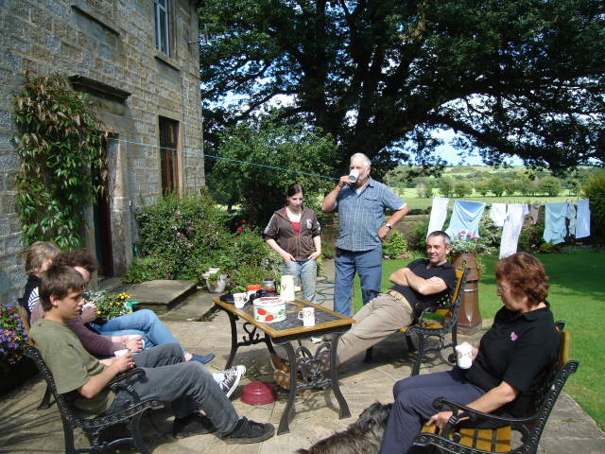Aunty Marge came on the bus for a sunny day on the boat. We pottered around doing boaty chores like filling up with diesel then went for a little trip. Uncle Pat and Cousin Nicky joined us for supper.
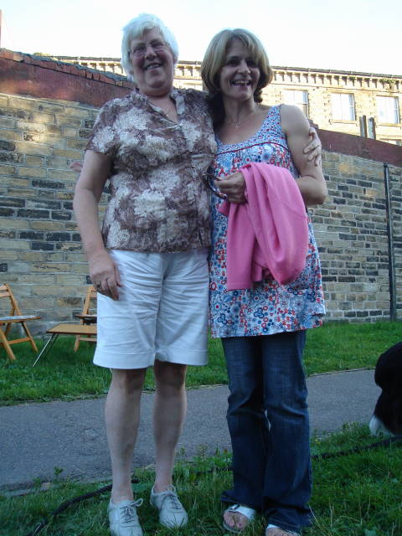
Cracking shorts Aunty Marge!
My eldest cousin Norman and his wife Margaret joined us for lunch and an afternoon’s boating. We went from Gargrave to Skipton, so we experienced locks and swing bridges. Norman was able to point out interesting landmarks, such as the children’s home where Dad’s sisters and youngest brother had lived for a while when the family broke up.
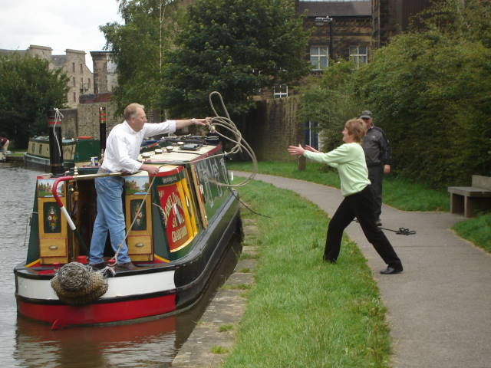Above ‘Captain’ Norman expertly throws a mooring rope to Margaret.
We popped in to see Norman’s Dad, Uncle Richard (named after his father, my grandfather) and Mum, Elsie. They had recently lost their little dog, and with Roly now 17, I could sympathize. We reciprocated with tea on the towpath. We could not persuade Elsie onto the water, but we couldn’t keep Richard off the boat.
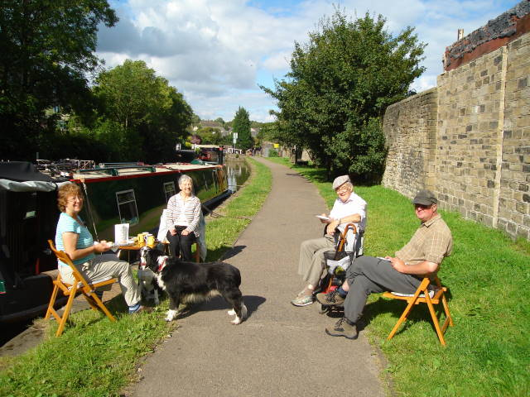
More boating next month, as we make our way up the Trent via Paul’s brothers at Lincoln and Langley Mill- weather permitting.
_________________________________________________
Log for July
Start: Skipton
Finish: Skipton
Miles: 37
Locks:6 _________________________________________________

